

**Installing Internet Information Services**

## 

## PROJECT REPORT SUBMITTED FOR SKLII ORIENTED COURSE:

**20IT4607:: EHTICAL HACKING**

**208W1A1298-MD.Neelofar Jaha**

**208W1A1299-MD.Rizwanullah**

**208W1A12A0-M.J.N.V.Sai**

**208W1A12A1-N.Ajay Kumar**



**DEPARTMENT OF INFORMATION TECHNOLOGY**

**V R SIDDHARTHA ENGINEERING COLLEGE**

**(AUTONOMOUS - AFFILIATED TO JNTU-K, KAKINADA)**

**Approved by AICTE &Accreted by NBA**

**KANURU, VIJAYAWADA-7**

**ACADEMIC YEAR**

**(2021-22)**

**TABLE OF CONTENTS**

1. **Problem Statement**
2. **Introduction**
3. **How IIS works**
4. **Install Internet Information Services**
5. **Using Web browser to check that it was installed correctly by considering an example.**
6. **Conclusion**

**1.Problem Statement**

Install IIS on your Windows computer.

Description: To create a Web site, you need to install IIS on your Windows computer. Although IIS is deployed on a server in a production environment, preproduction Web development and testing are typically done on workstations. IIS 5.1 is available in Windows XP Professional, IIS 7 is available in Vista (Business, Ultimate, and Enterprise editions), and IIS 7.5 is available in Windows 7 (Professional, Ultimate, and Enterprise). Because IIS isn’t installed by default, in this activity, you install it and use your Web browser to check that it was installed correctly

**2. Introduction**

Internet Information Services (IIS) is a flexible, general-purpose web server from Microsoft that runs on Windows systems to serve requested HTML pages or files.

An IIS web server accepts requests from remote client computers and returns the appropriate response. This basic functionality allows web servers to share and deliver information across local area networks ([LAN](https://www.techtarget.com/searchnetworking/definition/local-area-network-LAN)), such as corporate intranets, and wide area networks (WAN),such as the Internet.

A web server can deliver information to users in several forms, such as static webpages coded in HTML; through file exchanges as downloads and uploads; and text documents, image files and more.

### 3.How IIS works

IIS works through a variety of standard languages and protocols. HTML is used to create elements such as text, buttons, image placements, direct interactions/behaviors and hyperlinks. The Hypertext Transfer Protocol ([HTTP](https://www.techtarget.com/whatis/definition/HTTP-Hypertext-Transfer-Protocol)) is the basic communication protocol used to exchange information between web servers and users. [HTTPS](https://www.techtarget.com/searchsoftwarequality/definition/HTTPS) -- HTTP over Secure Sockets Layer (SSL) -- uses [Transport Layer Security](https://www.techtarget.com/searchsecurity/definition/Transport-Layer-Security-TLS) or [SSL](https://www.techtarget.com/searchsecurity/definition/Secure-Sockets-Layer-SSL) to encrypt the communication for added data security. The File Transfer Protocol (FTP), or its secure variant, FTPS, can transfer files.

Additional supported protocols include the Simple Mail Transfer Protocol ([SMTP](https://www.techtarget.com/whatis/definition/SMTP-Simple-Mail-Transfer-Protocol)), to send and receive email, and the Network News Transfer Protocol, to deliver articles on USENET

**4. Installing IIS in Windows**

 IIS or Internet Information Services is available in most editions of Windows, though disabled by default. manually. This article explains how to install IIS on a Windows 10 machine.

**To enable IIS on a Windows 10 computer, do the following:**

1.Open the Start menu.

2. Open the Control panel app.

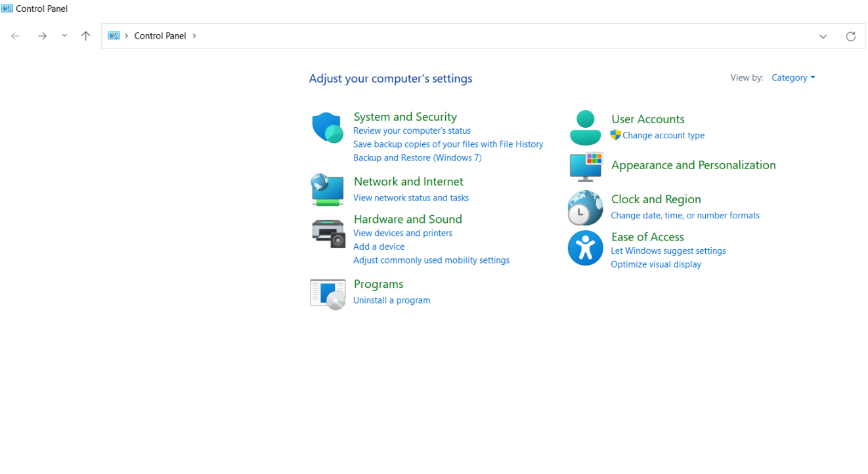

3. Go to Programs 🡪In programs and features🡪 Select Turn Windows festures on and off.

4. Then the below Window will open and Click on Internet Information Services Option and Then select Ok option .

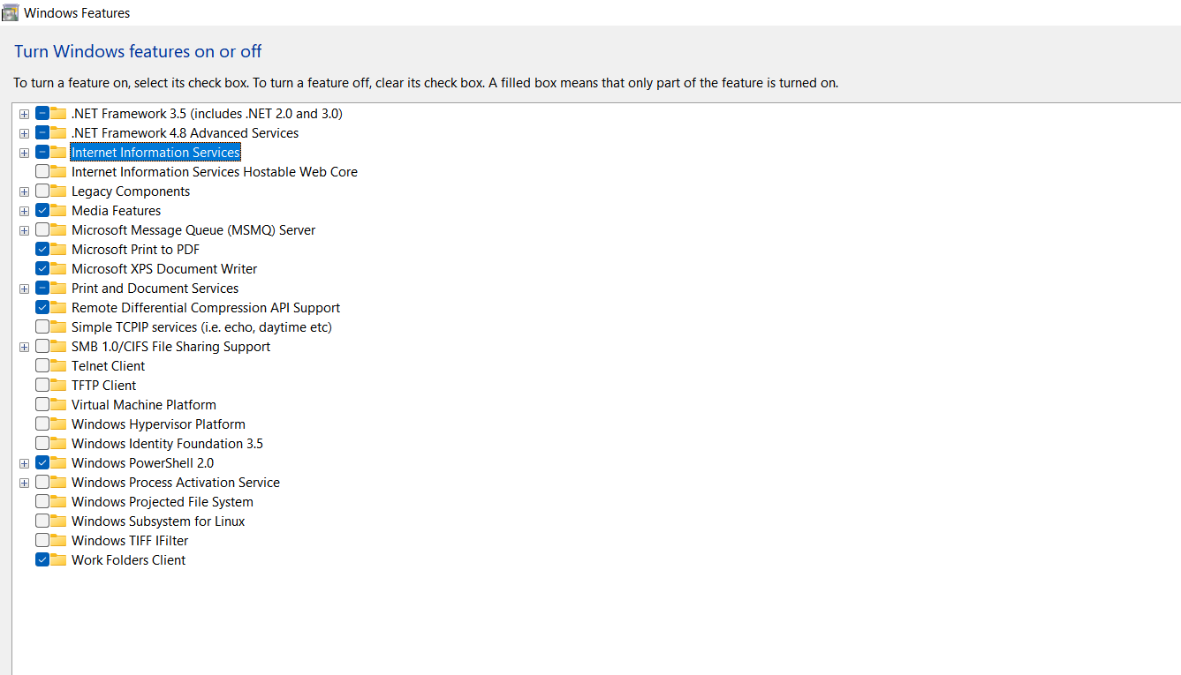

5. After selecting Ok. Just **Wait for the installation to complete** and hit Close.

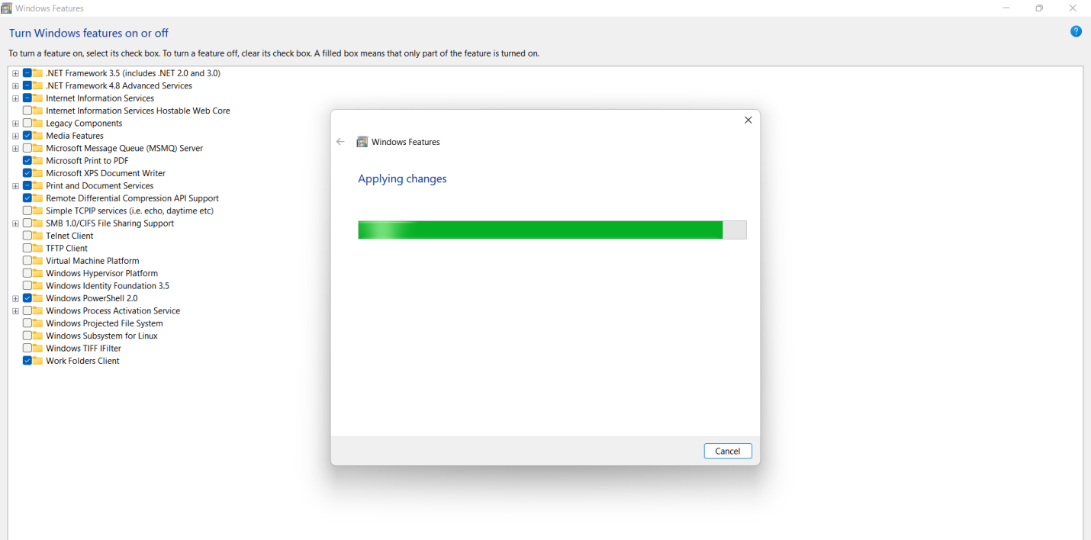

6.Our Installation is completed. After Installation Just go to Start and Search for IIS.

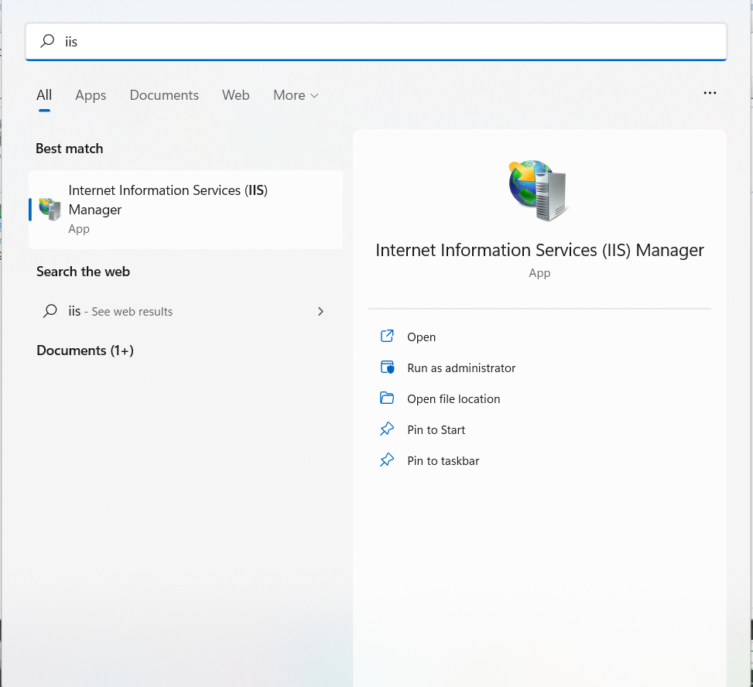

7. This is how the Internet Information Panel looks like.

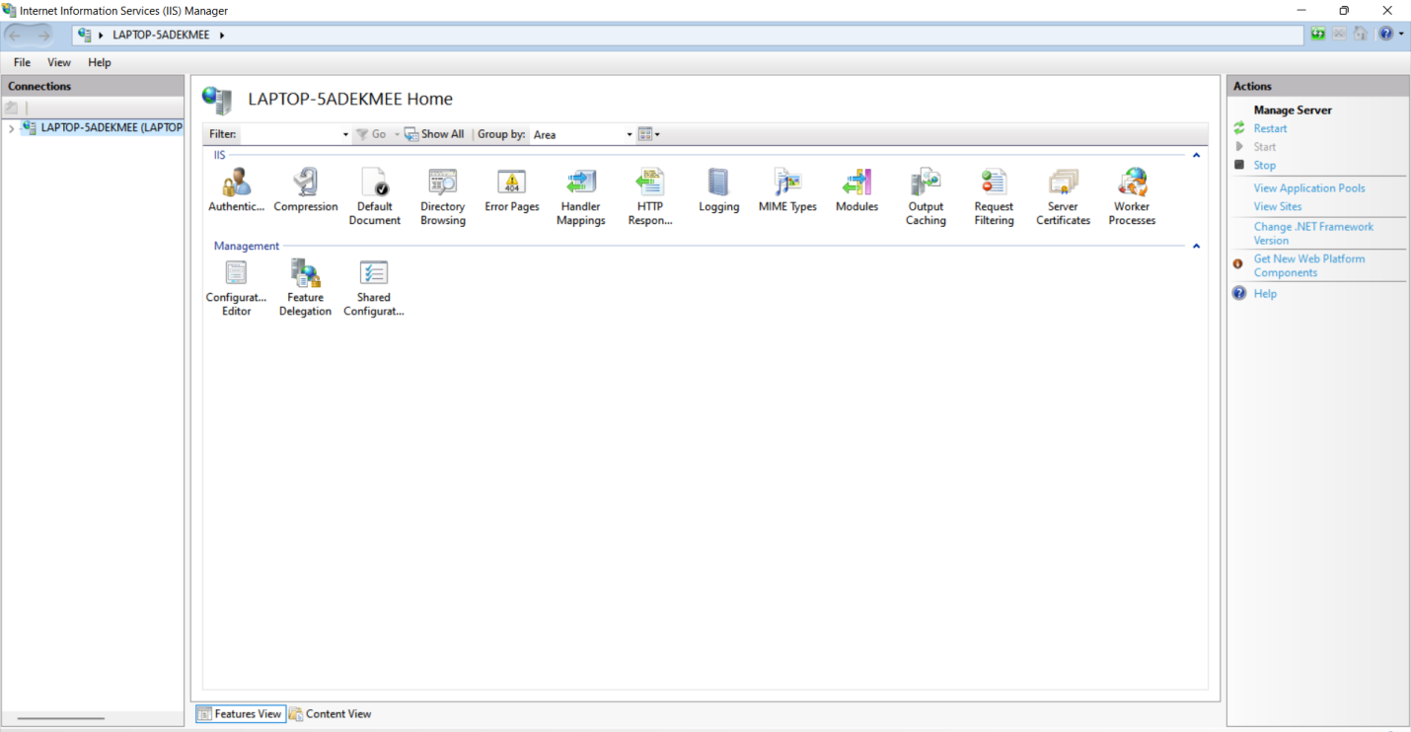

**5 .Using Web browser to check that it was installed correctly by considering an example.**

For this we need to create a Html page.

1.First go to ISS and Click on Stop option there.

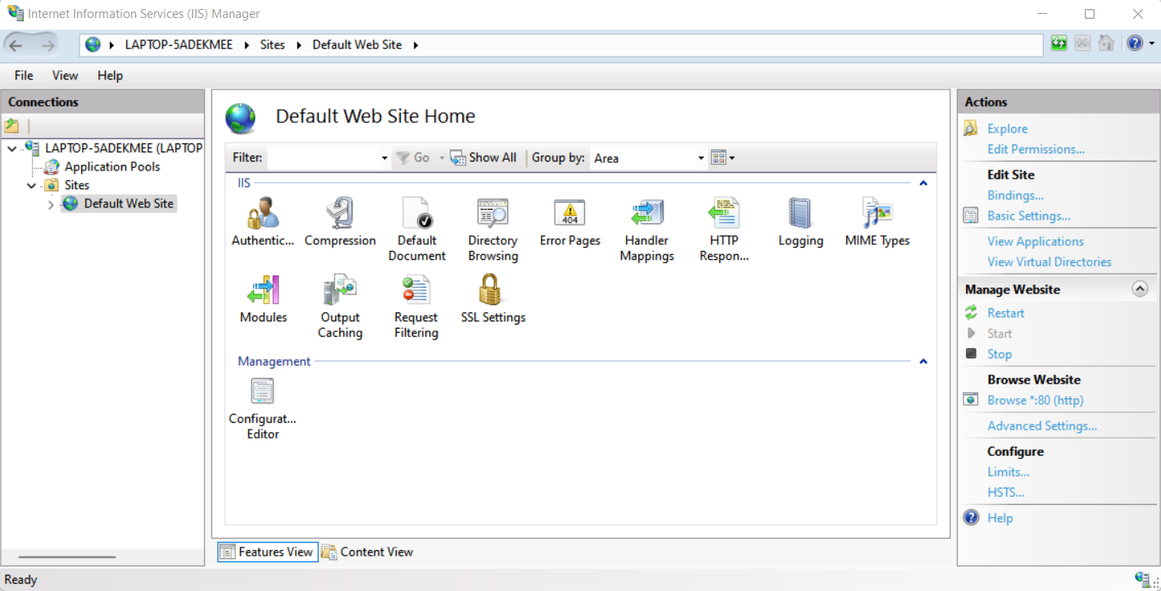

2.I have created a simple Html page and named it as index.html. This is how the webpage looks like.

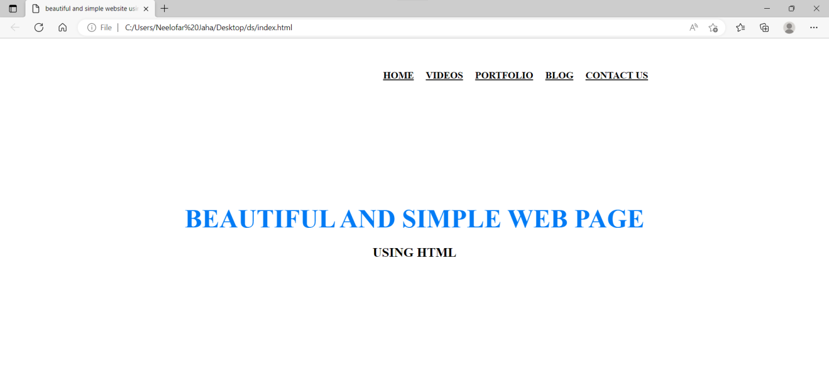

3 .Now copy your Html file index and Go to your Pc🡪select C Drive🡪 Click on the option Inerpub.

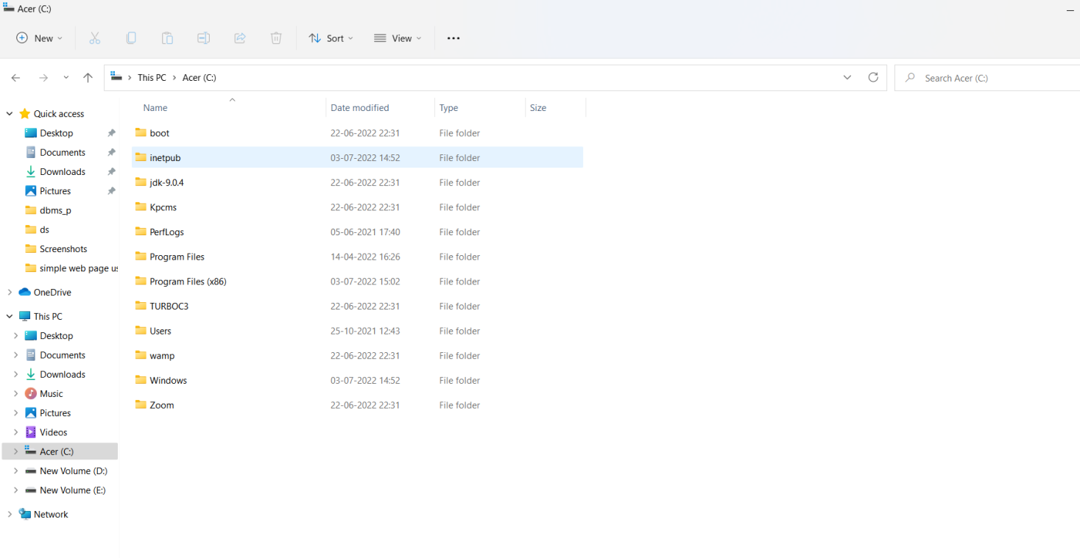

4.After that Click on the option called wwwroot.

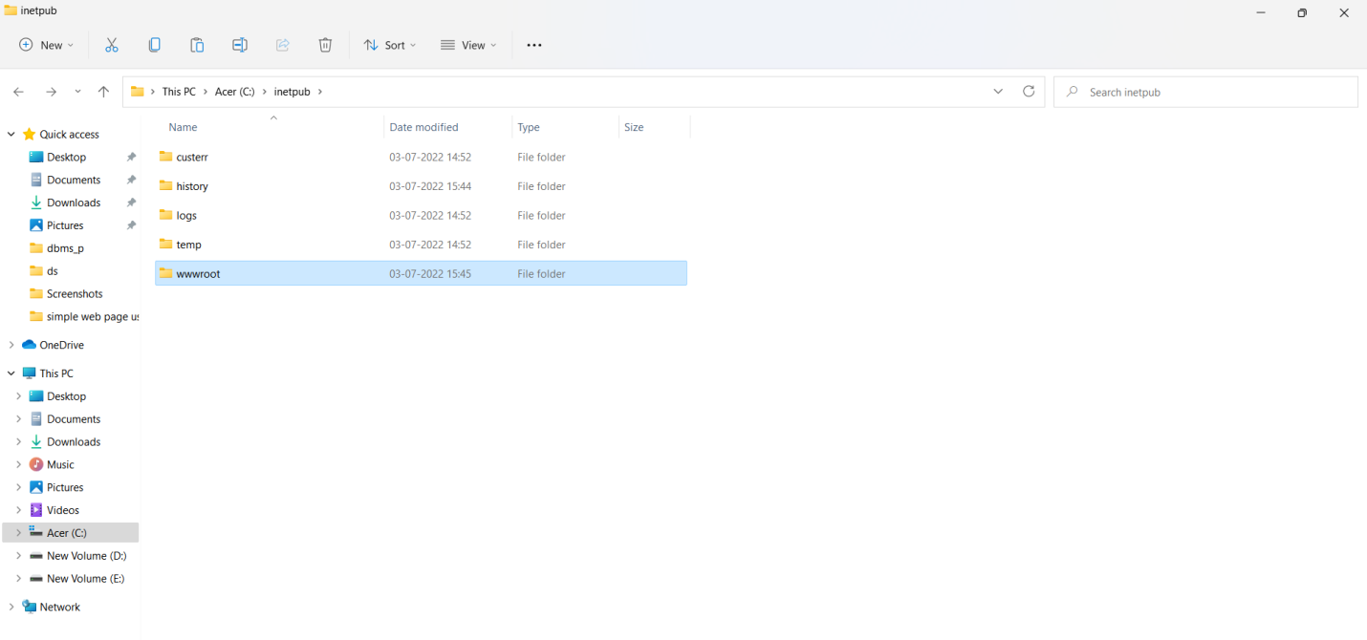

5 .Inside wwwroot clear all the files and place your Html index file .

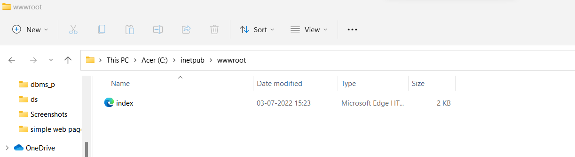

6.Now again go to Internet Information Services and click on start option.



7.Now Go to Web Browser and type your PC’s Ip address. The created Html page will be displayed.

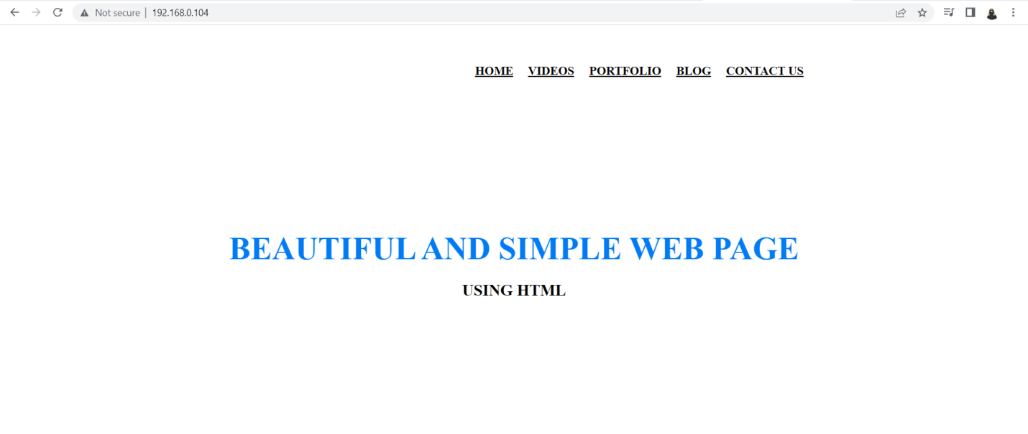

**6 .Conclusion**

This guide has outlined the step-by-step process for planning an IIS 7.0 infrastructure. By proceeding from step to step, major decisions regarding the IIS 7.0 infrastructure were revealed and explained. The guide has explained how to record choices of location, implementation method, server platform, server resources, and fault tolerance and make them available to infrastructure planners.

Using the information recorded from the steps completed in this guide, the organization can effectively deploy an IIS infrastructure with assurance that it is properly planned and prepared for a successful deployment.